4.8 Write Quadratic Equation - Given Vertex & Point
Find a quadratic equation in the form y = a(x – h)² + k given the vertex & a point. Show all work.
- Vertex (4, -3); contains (2, -1) ____________________

- Vertex (4, 5); contains (5, 3) ____________________

- Vertex (-3, 6); contains the origin ____________________

- Vertex (3, 5); y-intercept is 2 ____________________

- Vertex (-2, 6); y-intercept is -2 ____________________

- Vertex (4, 2); one x-intercept is 3 ____________________

- Vertex (-3, 4); one x-intercept is -1 ____________________

- Vertex (-4, 3); contains (-6, 11) ____________________

Find each of the following:
- If the parabola y – k = -3(x – 1)² passes through __________
the origin, find k.

- If the parabola y – 3 = a(x – 1)² passes through the __________
point (2, 5), find a.

- If the parabola y + 5 = a(x + 2)² has y-intercept 4, __________
find a.

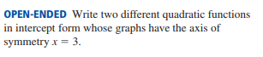
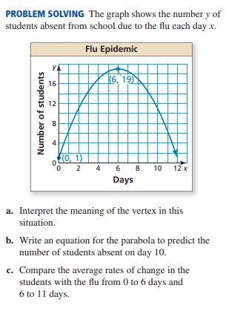
Work on Separate piece of paper.
- 13.

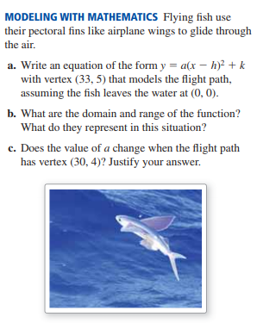
14.

Factor and solve the following problems: Factors Solutions

15. y = 7x² + 15x + 2 __________________________ _______________

16. y = 6x² + 11x + 3 ___________________________ _________________

17. y = 4x² - 8x - 5 __________________________ _________________

18. y = 2x² - 6x + 4 ____________________________ _________________

19. y = 9x² - 256 ____________________________ _________________

Solve the following problems by completing the square:
20. 5x² + 2x - 3 = 2 - 3x __________________________

21. 3x² + 2x - 1 = 3 ____________________________

22. 3x² + 6x -5 = 4 ____________________________

